Youssef Alchaer

Dr. Ghassem Tofighi

INFO40975 Artificial Intelligence

2022-12-03

Abalone Analysis: Abstract of research

This research project illustrates the use of Linear Regression AI algorithm on the Abalone Data Set. In that, we gathered Data to be analyzed to predict the *age* value. Based on the results we can see a direct correlation between rings, length and shell weight as being the most important feature to predicting the age. The prediction error was very low, however, near the top where the age was at a greater value we can see fluctuation. Since we split the data for training and testing, the results show that the model is reasonably accurate. Not all the results are on point with the test values, especially when you have a value higher than 15 illustrated in fig (1).. Between all the models available I executed lr(Linear regression) due to the highest efficiency and most accurate results.

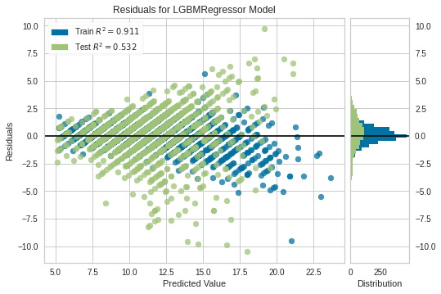 fig (1)